**USER MANUAL**

**Victoria State Accident Dashboard**

**Submitted By:**

**GROUP 33**

Augustine Kim | s5125270

Kai Chun Yu | s5309764

Ann Tapiador | s5314834

Table of Contents

1.0 Overview 3

2.0 Computer Settings 3

3.0 Parts of the User Interface 4

4.0 How to Display Graphs 5

5.0 How to Display Table 7

6.0 Troubleshooting 9

# Overview

This document details how users can utilize the system to show the graphs and the table. The system will only work using a desktop or laptop. It also works on both MAC OS and Windows. It will more likely also work using Linux but has not been tested yet.

Ensure that Python is installed. The terminal or command line can then be used to run the program using Python. Other Integrated Development Environment (IDE) such as Visual Studio or PyCharm can also be utilized.

**Required:**

<https://www.python.org/downloads/>

**Optional:**

<https://code.visualstudio.com/download>

<https://www.jetbrains.com/pycharm/download/?section=windows>

# Computer Settings

For all the details to be displayed within the window, the recommendation is to set the computer’s resolution to the highest. Normally, laptops that run on MAC OS no longer need to adjust the resolution. For Windows users however, the recommendation is to adjust both the scale and resolution as shown below:

1. Go to your search box, type display settings, and click on it.

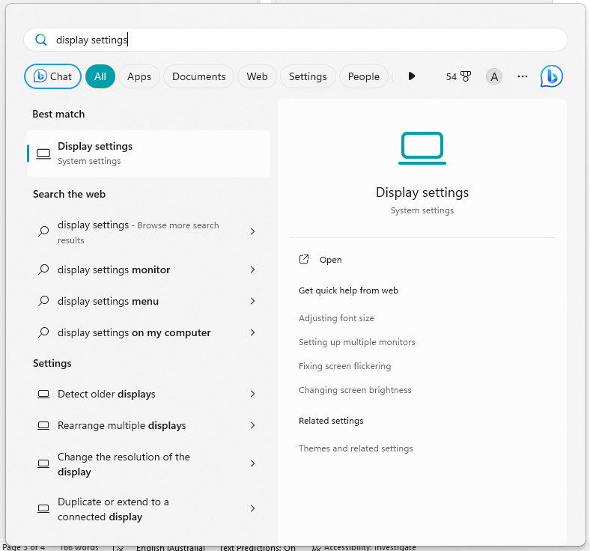

1. Adjust scale to 100%, and adjust resolution so that it is in its highest settings (for windows, recommendation is 1920 x 1080)

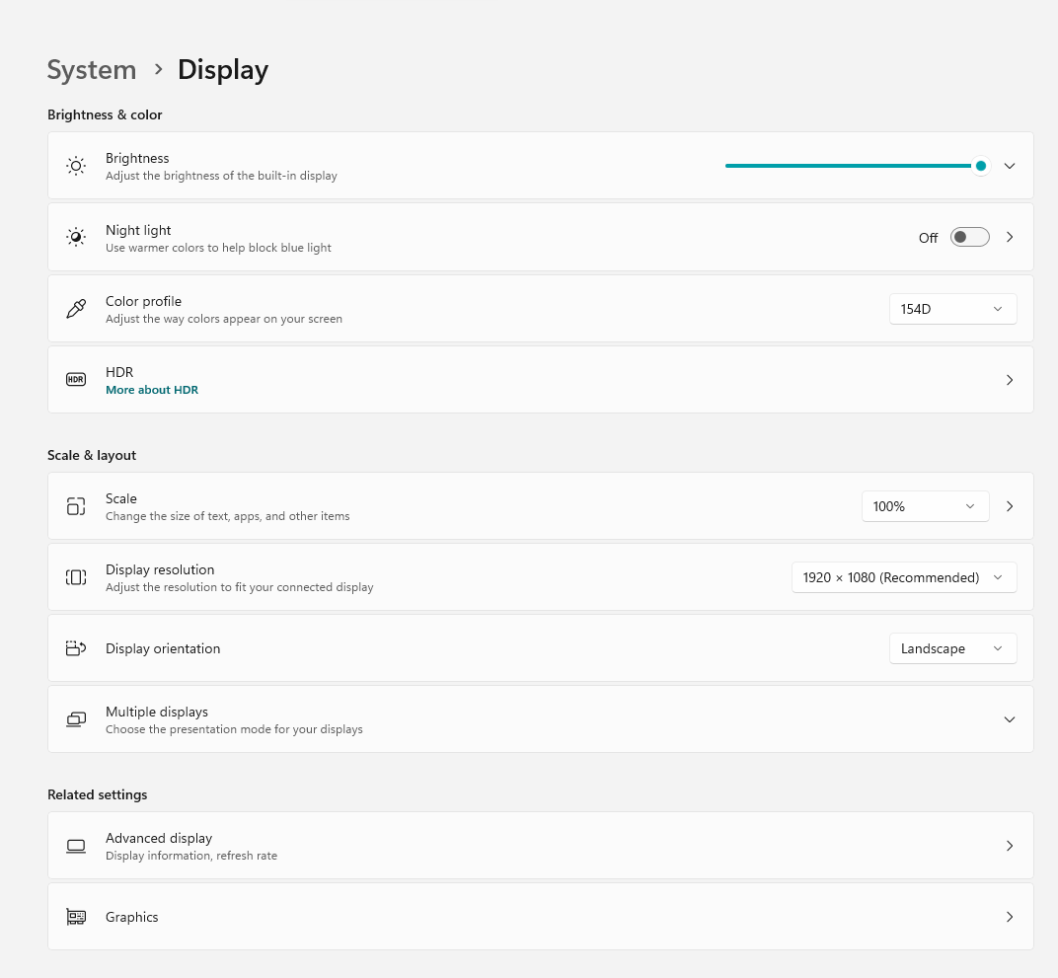

# Parts of the User Interface

1. When you run the program, adjust the window to its maximum size to get the full view.

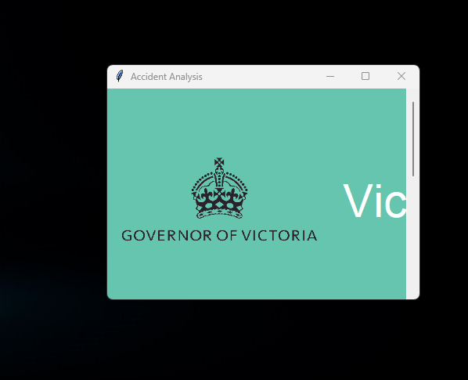

1. This will show you the following main sections:
2. The section that will display the graphs.
3. The section that will display the table.
4. User Manual section, which is a condensed instruction guide for quick start.

1. The parameters to show the graph is separate from the parameters for the table. This is why each section has its own input fields for start and end dates.

# How to Display Graphs

1. Choose the desired start and end dates. Ensure that it falls between the available dates on the database, i.e., 2013/07/01 to 2019/03/21 as shown on the instruction above the input fields. The format must also follow YYYY/MM/DD.

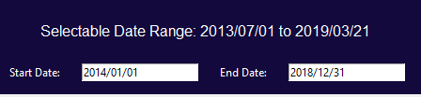

1. If an invalid input is used, an error message appears. Close the box and revise using a valid date range and date format.

1. Click the dropdown box and choose whether to show only alcohol-related accidents, non alcohol-related accidents, or both.

1. Click the dropdown box and choose the category of accident data to be displayed, i.e., if by accident type, by severity, or by region name. The result will display the sub-categories of the said category.

For reference, below is the list of sub-categories:

* + 1. ACCIDENT_TYPE
       1. Collision with a fixed object
       2. Collision with some other object
       3. Collision with vehicle
       4. Fall from or in moving vehicle
       5. No collision and no object struck
       6. Other accident
       7. Struck animal
       8. Struck pedestrian
       9. Vehicle overturned (no collision)
    2. SEVERITY
       1. Fatal accident
       2. Non injury accident
       3. Other injury accident
       4. Serious injury accident
    3. REGION_NAME
       1. Eastern Region
       2. Metropolitan North West Region
       3. Metropolitan South East Region
       4. North Eastern Region
       5. Northern Region
       6. South Western Region
       7. Western Region

1. Once all parameters are set, click the search button

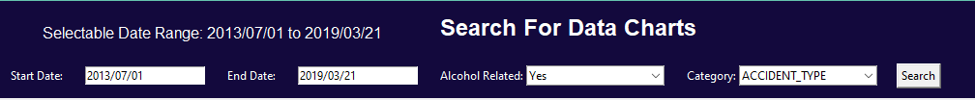

1. The result will display 3 charts. Use the scroll bar at the right side to show the charts further down the window.
   1. The first will show a line graph containing the average number of accidents per hour based on the set parameters.
   2. The second will show a bar graph containing the total number of accidents based on its relation to alcohol, and on the sub-categories of the selected category.
   3. The third will show a line graph containing the total number of accidents based on its relation to alcohol, and the corresponding months within the selected date range. Each sub-category from the chosen category will be displayed in separate lines to show the monthly trend of each over the said period.

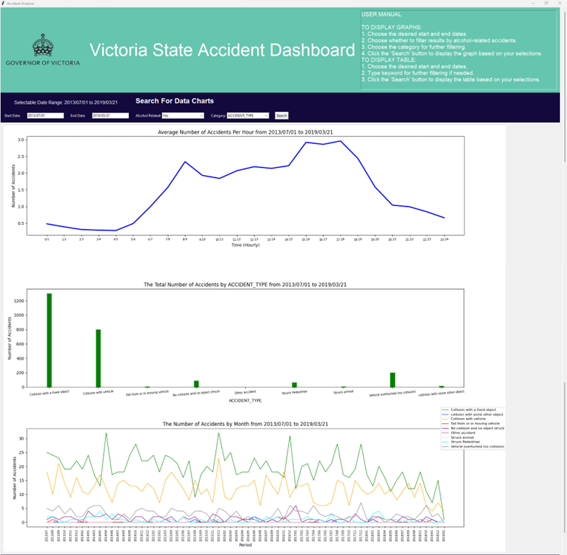

# How to Display Table

1. Choose the desired start and end dates. Ensure that it falls between the available dates on the database, i.e., 2013/07/01 to 2019/03/21 as shown on the instruction above the input fields. The format must also follow YYYY/MM/DD.



1. If an invalid input is used, an error message appears. Close the box and revise using a valid date range and date format.

1. There is an option to use keywords to further filter the search, but this may also be left blank if there is no desire to further filter the data.



1. Once all parameters are set, click the search button.



1. The result will display the results in a table. This will only display the first 10 results. To further read the data on the succeeding rows, hover the mouse over the table and scroll down.

# Troubleshooting

In general, the graphs and tables are immediately generated after the search button is clicked. However, in the event that the system lags, close the program and restart.